Q1. Write the major elements of Promotion Mix to promote a newly launched ice cream “Yummy” in the Indian Market. Explain all the elements in detail so that the awareness and sales increases for the Brand?
Ans.

1. Advertising :
Advertising is the main factor by which awareness of a product can be generated in market.
It is done by posting printed flexes around the target area, television advertisement is the major source of advertisement in indian house. Social media marketing is major tool of advertisement in today's digital work. Sales in today's world is directly proportional to the quality of advertising.

2. Personal selling :
In this the organisations hire sales person who market their product by meeting potential clients.
Ice Cream is a product which can be placed anywhere with any kind of commodity. This makes it easier to identify market and approach them. Personal selling also helps in awareness of product through the targeted market.

3. Public relations :
Public relations are most important to maintain the product quality and brand image. Constant feedback while interacting with public helps in making the required changes to overcome defects and raise sales factor.

4. Direct Marketing :
Direct marketing is a form of advertising which allows businesses and nonprofit organizations to communicate directly to customers through a variety of media including cell phone, text messaging, email, websites, online adverts, database marketing, fliers, catalog distribution, promotional letters and targeted television, newspaper and magazine advertisements as well as outdoor advertising.

5. Sales Promotion
Sales promotion includes several communications activities that attempt to provide added value or incentives to consumers, wholesalers, retailers, or other organizational customers to stimulate immediate sales. These efforts can attempt to stimulate product interest, trial, or purchase.

Q2. Assume you are the Marketing Manager of a company “Keep Talking” which manufactures the mobile in Indian Market. Currently the company holds a good market share in smartphone category. You are of a belief that the company should launch some new tablets. What steps you would follow to launch the new product (tablet) in the market?

Ans.

1. Understanding current market :
As the company holds a good market in smartphones it is of outmost importance to understand the current market. Queries like satisfaction, interest and demand parameter can be best extracted from the current market. If people show interest with the introduction of new features via tablet, confidence of product sale can be built up. Study also helps in customising the new produce according to the reviews shared by people. This process can be carried over surveys, social media marketing to record the demand parameter on the basis of which production factor can be adjusted.

2. Targeting new Market :
Scaling of a business is the key aspect of increased business profit. According to the study of current market, manager can gain insights for the target market. Market which most resembles the culture, lifestyle and economic conditions same as the current market can be set as target market.
While targeting the market it is of major concern as a manager to study the competitors and their brand, to better deploy the product generating its USP.

3. Features :
Features are the key points of sale and popularity of a product. Introduced tablet features must be unique or unique quality that can fight the market as a standalone feature. It can be made cost effective which is considered as a feature in today's world.
For Ex: BSNL launched AAKASH tablet's with the same features as market already had but ran successful due to its low pricing. Price was so comfortable that a normal individual won't think twice to buy.

4. Production Factor :
Production factor is directly related to the market demand of the product. If the response of the product in market is good, production factor increases and vise versa. It plays a major role in increased market price due to shortage. It is very important to maintain a balance for this factor as long term production fail can kick out the product off market.

5. Sales/Marketing :
This is lifeline of product sale and market growth of product. Various plans are implemented to study the potential clients and generating awareness of the product by personal selling, advertising etc. Follow up is main process to be carried over in this field.

6. Documentation :
History lies within the documentation. Market study, recession period, demand time are best studied with documentation. Various tools are available in market to analyse the data, strategic tools can be used to critically analyse the demand time. Documentation also helps in overcoming the previous mistakes done by the organisation to enhance overall productivity.

7. Goals :
A defined goal is very important for an organisation to climb the ladder for success. Goal generates specific set of procedures to be followed by by a manager to achieve certain objective. It helps the manager to keep on track and focus on the key aspects to move ahead gradually.
Q3. Segmentation, Targeting, Positioning and Differentiation plays a very important role in the success of any product?

a) Critically evaluate the market segments for Apple, Micromax and Samsung in India.

Ans.

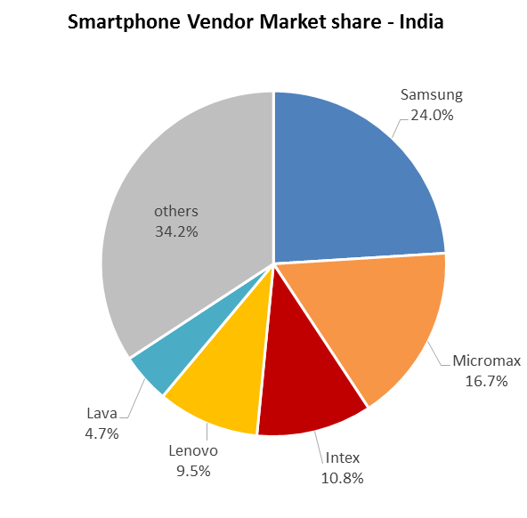

Market segment for Apple :

1. Sales of Apple's iPhone in India are so vanishingly small that the company ranks 18th among smartphone vendors, with a meager 0.9 percent of shipments.

2. In India, luxurious, showoff segment exists but there is more of a frugality mentality so people want to be seen to have made a smart purchase rather than an expensive purchase which is intrinsically linked with financial status of common people.

3. Apple currently has a 2 percent smartphone market share in India.

Market segment for Samsung :

1. Samsung's market share in the smartphones segment in India went up from 35.1 percent to 45.9 percent during 2015.

2. Samsung has overall market share of 44 percent across all segments.

b) Critically evaluate the positioning and differentiation strategy for Micromax, Samsung,
Lenovo and Apple in India.

Ans.

MICROMAX :

Positioning :
Micromax entered the mobile business in 2010, this four-year old company went head on with Samsung last year, which really encapsulated its ambition. The new report by counterpoint research points out that with 16.6 percent mobile market share Micromax has overtaken samsung as the largest mobile phone supplier in 2014. Counterpoint also points out that Micromax now has 19.1 percent share and is the second largest smartphone brand in terms of shipments.
Micromax wasn’t building its own phones, but selling white label devices imported from China, rebranded in India.

Differentiation strategy :
The company has ensured it survives the market by adapting to the changing market dynamics through the introductions of feature-rich smartphones and phones that are mostly a “me too product” and enter the market at an aggressive price. The company enjoys an impressive 22% market share in the smartphone segment in India, with its excellent marketing mix.

SAMSUNG :

Positioning :
The company retained its position as the No.1 phone maker with 18.7% market share in the overall mobile phone market in the country. Samsung remained aggressive in terms of promotion during the quarter with its Flagship models S6 and S6 Edge launch.

Differentiation strategy :
- Curated pre-installed business apps on Galaxy S6.
- Tight integration with PC software that businesses use

LENOVO :

Positioning :
Lenovo, India's third-largest smartphone maker. In India, Lenovo did not figure in the top 5 tally as of October-December 2014 quarter.

Differentiation strategy :
- Price in the marketing mix of Lenovo
Lenovo is priced competitively when compared to other top brands. In fact, in some areas like accessories it also uses penetrative pricing.
- Place in the marketing mix of Lenovo
Lenovo has exclusive showrooms as well as multi brand showrooms. It markets itself through modern retail, E commerce chains, and majorly through the vast numbers of IT and peripheral shops present across the country.
- Promotions in the marketing mix of Lenovo
Due to its products, Lenovo has a certain measure of headway when it concerns the promotions department. The technology segment and especially the IT market is filled with competitors like HP, Dell and Microsoft to make the competition very high in the segment.

APPLE :

Positioning :
Apple is currently occupying the "white hot center" of converged personal computing & entertainment market, and that's a tough position to beat for any competition. So the best solution in such a case is to lure customers into a different market place - i.e, enterprise market place. e. g Apple, by nature & by business strategy, has never positioned itself in the enterprise space & that opens an opportunity for competitors like HP, Blackberry & others.

Differentiation strategy :
- Premium pricing
- Branding
- Differentiation
The company’s products have always been designed to be ahead of the curve compared to its peers.

